2018 S.C. GOVERN0R’S CUP

TAEKWONDO CHAMPIONSHIPS
Saturday, September 29th 2018
Rocky Creek Church Gymnasium
1801 Woodruff Rd., Greenville, S.C. 29607
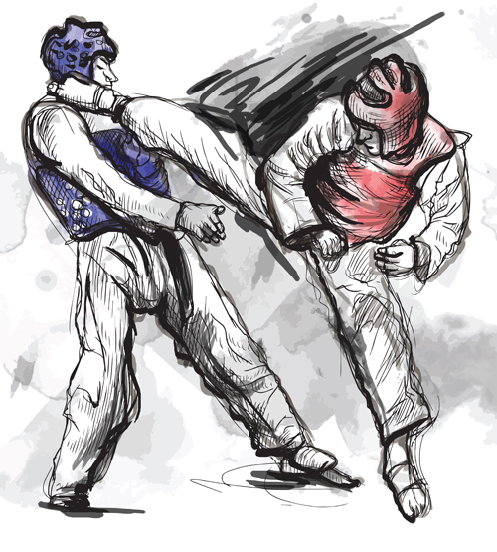
New!!
Self Defense
One Step
competition

Beautiful Custom Medals!

Poomsae
Black Belt Grand Championship
12 & up divisions
Daedo
Electronic
Scoring System

Hosted by Huggins Tae Kwon Do Academy
Tournament Directors: Grandmaster Bill & Ann Huggins
Competitor Check-In Wave One (6 through 11 years old all belts): 8:00am to 8:45am
Officials meeting 8:45am
Wave One Competition: 9:00 am – 12:00 pm
Competitor Check-In Wave Two (12 yrs old & Up…all belts): 12:00 pm through 12:45 pm
Wave Two Competition: 1:00 pm until finished (all times approximate)

For further information call Huggins Tae Kwon Do Academy: (864) 297-9420
Tournament Packets at www.hugginstkd.net
See you all at the Governor’s Cup!!

Spectator Admission: $5.00
Children 6 & under Free
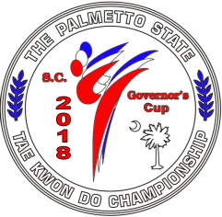

2018 S.C. GOVERN0R’S CUP TAEKWONDO CHAMPIONSHIPS
Saturday, September 29th 2018
Rocky Creek Church Gymnasium
1801 Woodruff Rd., Greenville, S.C. 29607
Spectator Admission $5.00 Children 6 & under FREE

PRE-REGISTRATION ONLY
Competition Fee: (one or two events) $75.00 Three events:$80.00
Must be received by Friday, September 21st
Late registration: $85.00 received by Tuesday, September 28th.
Competitor Fees are Non-Refundable…No registration accepted after Sept. 28th

OFFICIAL COMPETITOR’S ENTRY FORM

Name: ______________________________________________________ Phone: __________________
Address: _____________________________________________________________________________
City: _________________________________ State: ___________ Zip: __________________________

ALL OF THE FOLLOWING INFORMATION MUST BE COMPLETED IN FULL OR APPLICATION WILL NOT BE ACCEPTED (weight must be accurate!!!)
Age: _____ Date of Birth: ____________ Sex: _______ Height: ____________ Weight: ___________
Belt Color: ______________________ Rank/Belt Color: _________________________
Tae Kwon Do School: __________________________________________________________________
Instructor: ___________________________________________________________________________
Events Entering (check): Poomse (forms): ______ One Step/Self Defense:______Gyuroogi (sparring):______
Please pay by Money Order or Check: Payable to Huggins Tae Kwon Do Academy
Mail to Huggins Tae Kwon Do Academy, 419 North Main Street, Mauldin, S.C. 29662
Phone: (864) 297-9420 e-mail: whuggins1572@att.net

In consideration of your acceptance of my entry to this event, I do hereby, for myself, my heirs, executors, and administrators, waive, release and forever discharge all rights and claims for damages which I may have, or which may occur to me against MTA, Inc. dba Huggins Tae Kwon Do Academy, the tournament directors, Rocky Creek Church and its representatives, all members of the tournament, or their respective officers, agents, successors, and representatives, and against any competitor for any and all damages which may be sustained by me in connection with my association with, or entry in the above athletic meet. I understand that Taekwondo is a body contact sport, which involves risk of injury. I agree to all tournament competition rules and understand that I may be disqualified if I do not follow these rules.

Applicant Signature: ________________________________________________Date: _____________

Guardian (if under 18): ______________________ Relation: _______________Date: ______________

2018 S.C. GOVERN0R’S CUP TAEKWONDO CHAMPIONSHIPS
Saturday, September 29th 2018
Rocky Creek Church Gymnasium
1801 Woodruff Rd., Greenville, S.C. 29607

Coaches Pass
One Free Coaches Pass per school (Additional passes $10.00 each)
Please check: _____$10.00 Free Pass (one only)______

Name: ______________________________________________________ Phone: __________________
Address: _____________________________________________________________________________
City: _________________________________ State: ___________ Zip: __________________________

Age: ____ Date of Birth: __________ Sex: ____ Belt/Rank in Taekwondo:______________________
Tae Kwon Do School: ______________________________Instructor: ___________________________

Please pay by Money Order or Check: Payable to Huggins Tae Kwon Do Academy
Mail to Huggins Tae Kwon Do Academy, 419 North Main Street, Mauldin, S.C. 29662
Phone: (864) 297-9420 e-mail: whuggins1572@att.net

In consideration of your acceptance of my entry as a coach in this event, I do hereby, for myself, my heirs, executors, and administrators, waive, release and forever discharge all rights and claims for damages which I may have, or which may occur to me against MTA, Inc. dba Huggins Tae Kwon Do Academy, the tournament directors, Rocky Creek Church and its representatives, all members of the tournament, or their respective officers, agents, successors, and representatives, and against any competitor for any and all damages which may be sustained by me in connection with my association with, or entry in the above athletic meet. I agree to all tournament competition rules and understand that I may be disqualified as a coach if I do not follow these rules.

Applicant Signature: ________________________________________________Date: _____________

Guardian (if under 18): ______________________ Relation: _______________Date: ______________

2018 S.C. GOVERN0R’S CUP TAEKWONDO CHAMPIONSHIPS
Saturday, September 29th 2018
Rocky Creek Church Gymnasium
1801 Woodruff Rd., Greenville, S.C. 29607

VIP/School Instructor/Masters Pass
No charge but must register by deadline for approval

Name: ______________________________________________________ Phone: __________________
Address: _____________________________________________________________________________
City: _________________________________ State: ___________ Zip: __________________________

Age: ____ Date of Birth: __________ Sex: ____ Belt/Rank in Taekwondo:______________________
Tae Kwon Do School: ______________________________Instructor: ___________________________

Please pay by Money Order or Check: Payable to Huggins Tae Kwon Do Academy
Mail to Huggins Tae Kwon Do Academy, 419 North Main Street, Mauldin, S.C. 29662
Phone: (864) 297-9420 e-mail: whuggins1572@att.net

In consideration of your acceptance of my entry as a VIP/Instructor/Master in this event, I do hereby, for myself, my heirs, executors, and administrators, waive, release and forever discharge all rights and claims for damages which I may have, or which may occur to me against MTA, Inc. dba Huggins Tae Kwon Do Academy, the tournament directors, Rocky Creek Church and its representatives, all members of the tournament, or their respective officers, agents, successors, and representatives, and against any competitor for any and all damages which may be sustained by me in connection with my association with, or entry in the above athletic meet. I agree to all tournament competition rules and understand that I may be disqualified as a guest if I do not follow these rules.

Applicant Signature: ________________________________________________Date: _____________

Guardian (if under 18): ______________________ Relation: _______________Date: _____________

SC Governor’s Cup
Event T-shirt Order Form

$15 per shirt
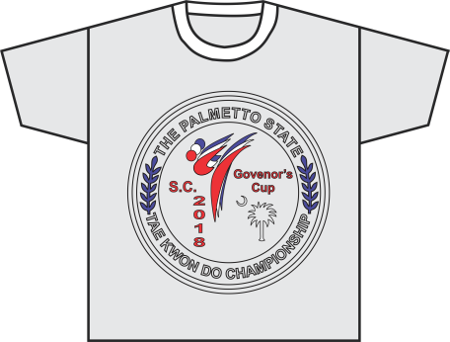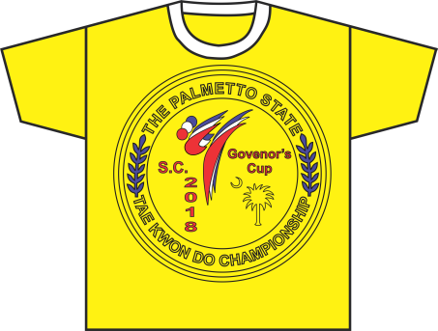
Ash Yellow/Gold
Name: ________________________________________TKD SCHOOL___________________________________

Address: _____________________________________________________________________________________

Phone Number: __________________________ E-mail: ___________________________________________

THIS IS A SEPARATE PAYMENT NOT TO BE INCLUDED WITH TOURNAMENT FEE.
Please follow directions carefully!!
Checks payable to Paul Guiry. Mail order forms to Sumter Tae Kwon Do, 1147 N. Guignard Dr. Unit 1, Sumter, SC 29150. E-Mail form to SumterTKD@hotmail.com No Later Than 17 Sept 2018 No return or refund.
PRE ORDER ONLY…NO TEE SHIRTS WILL BE SOLD AT THE TOURNAMENT

QTY Yellow/Gold Shirt QTY Ash Shirt

Child Small __________ __________
Child Medium __________ __________
Child Large __________ __________
Child __________ __________
Adult Small __________ __________
Adult Medium __________ __________
Adult Large __________ __________
Adult X-Large __________ __________
Adult 2X and above (additional $4) __________ __________

Total Amount: ___________

2018 S.C. GOVERN0R’S CUP TAEKWONDO CHAMPIONSHIPS
Sparring Competition
Age groups:
Dragon: 6 & 7 years old
Ninja: 8 & 9 years old
Youth: 10 & 11 years old
Cadet: 12,13,14 years old
Junior: 15, 16, 17 years old
Senior: 18 – 32 years old
Ultra: 33 yrs & up

Belt Groups:
yellow/green
blue/red
black
Light, Middle, Heavy, Super Heavy
POOMSE (FORMS) COMPETITION
Age groups:
Dragon: 6 & 7 years old
Ninja: 8 & 9 years old
Youth: 10 & 11 years old
Cadet: 12,13,14 years old
Junior: 15, 16, 17 years old
Senior: 18 – 32 years old
Ultra: 33 yrs & up

Belt Groups:
yellow/green
blue/red
black

POOMSE & SPARRING DIVISIONS
ELIGIBILITY: Any students from legitimate Tae Kwon Do schools that are in good standing with their dojang and instructors.

POOMSE BLACK BELT GRAND CHAMPIONSHIP: 1st place Black Belt winners (male & female age 12 & up divisions) may compete for overall Grand Champion in Black Belt Poomse. You will perform your ranking Black Belt Poomse. There will be one male & one female Grand Champion.

***ONE STEP/SELF DEFENSE COMPETITION RULES: (12 & up Coed Event): Each competitor will execute Five separate self-defense one steps. One steps should include a combination of hand & foot techniques. Aside from strikes, blocks & kicks they may include sweeps, takedowns & throws. Each competitor must provide own partner. You will be given a score (1-10) based on speed, power, accuracy and practical application (effectiveness). Your partner can initiate the attack from a down block punch advance or from a standard fighting stance punch or kick attack.

SPARRING COMPETITION RULES: Please refer to S.C. Gov Cup rules on next page. Daedo electronic hogu scoring will be used for all Black Belts 10 years old & up.

AWARDS: Beautiful custom medals will be awarded to 1st, 2nd, and 3rd place winners. Two third place medals will be rewarded in sparring divisions. Poomsae Grand Champions will be rewarded Grand Championship trophies.
2018 S.C. GOVERNOR’S CUP SPARRING COMPETITION RULES

Duration of Matches: All belts & all ages = 2 one minute rounds with 30 seconds rest in between rounds.
USAT/WT Referees: All matches will be officiated by certified USAT/WT referees.
Rules regarding contact:
In divisions where head contact is allowed it should be controlled. Therefore excessive contact to the head should be avoided. Excessive contact to the head will result in a "Gam-jeom" or disqualification depending on severity.
◊ Adults 18 years and older (Color Belts & Black Belts): Full contact to legal body area with kicks and punches. Head contact is allowed but should be controlled.
◊ Ages 12 through 17 (Black Belts): Adult rules apply.
◊ Ages 12 through 17 (Color Belts): Full contact to the legal body area with kicks and punches. Kicks to the head will be allowed but must be light contact. Excessive force will result in a "Gam-jeom" or disqualification.
◊ Ages 8 - 11 (Black Belts): Full contact to the legal body area with kicks and punches. Kicks to the head will be allowed but must be light contact. Excessive force will result in a
"Gam-jeom" or disqualification depending on severity..
◊ Ages 11 years and under (Color Belts): Full contact to the legal body area but absolutely no contact to the head. Any contact to the head will result in a "Gam-jeom" or disqualification.

Valid Scores/Points:
◊ A valid punch to the body will be rewarded one point.
◊ A valid kick to the body will be rewarded two points. 1 additional bonus point for spinning kick.
◊ A valid kick to the opponent’s head will be rewarded three points. 2 additional bonus points for spinning kick to head in adult divisions only.

Penalty point (Gam-jeom)
Current USAT rules apply for sparring competition. When any of these rules are violated a "Gam-jeom" will be issued by the center referee. Coaches, please make sure your competitors are familiar with all sparring rules.

How a match is won: Taekwondo contests (this is a contest, not a fight:) have very specific and complex rules and regulations designed to ensure the safety of the competitors, to create a fair environment in which to compete and to promote ideal and appropriate technique. The object of the contest is to demonstrate technical superiority over ones opponent.
1. Win by K.O.
2. Win by Referee Stop Contest (RSC)
3. Win by score or superiority
4. Win by withdrawal
5. Win by disqualification
6. Win by Referee’s punitive declaration

